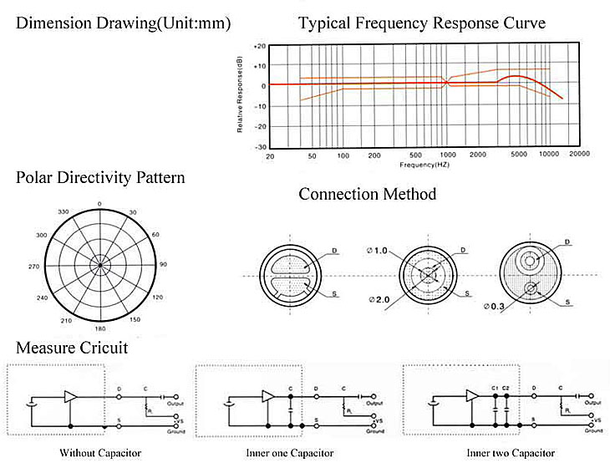
Detail Specifications：
Model No. | DGO9748CD
Sensivity(0dB=1v/μbar,1KHz) | -36dB ～ -46dB | Operation Voltage(Max./Std.) | 4.5V
Impedance | Low impedance(2.2KΩ-30% ) | Resistance(RL): | 2.2KΩ
Directivity | Omni-directinal | Current Consumption: | Max.0.5.mA
Frequency | 20~16，000Hz | Sensitivity Reduction | Within -3dB at 1.5V
Max.operation voltage | 10V | S/N Ratio | More than 58dB

